[Skip to main content](http://lmsweb.aast.edu/mod/assign/view.php?id=69827" \l "maincontent)

[AAST Moodle](http://lmsweb.aast.edu/)

* [SALMA ELSAYED BORHAM SOLYMANhttp://lmsweb.aast.edu/theme/image.php/clean/core/1587179240/u/f2](http://lmsweb.aast.edu/mod/assign/view.php?id=69827)

**Database Systems (IS273)**

Page path

* [Dashboard](http://lmsweb.aast.edu/my/) / ►
* My courses / ►
* [Database Systems (IS273)](http://lmsweb.aast.edu/course/view.php?id=2682) / ►
* Week 12 / ►

**Question 1:**

Consider a Small Private Airport database that is used to keep track of airplanes, their owners, airport employees, and pilots. From the requirements for this database, the following information was collected:

* Each **Airplane** has a *Registration Number (Unique)*, is of a particular *Plane Type*, and is stored in a particular *Hangar*.
* Each **Plane** Type has a *Model Number*, a *Capacity*, and a *Weight*.
* Each **Hangar** has a *Number*, a *Capacity*, and a *Location*.
* The database also keeps track of the **Owners** of each **plane** and the **Employees** who have maintained the **plane**.
* An **Owner** is either a **Person** or a **Corporation**. Also, the airport keeps track of the *Purchase Date*.
* Each Owner Person has *Social Security Number (SSN)*, *Name*, *Address*, and *Telephone Number.*
* For Owner Corporation, the airport kept track of *Name*, *Address*, and *Telephone Number*.
* Also, Each Employee has *Social Security Number (SSN)*, *Name*, *Address*, *Telephone Number, Salary* and *Shift.*
* The airport also keeps track of the **types of planes each pilot is authorized to fly**and the **types of planes each employee can do maintenance work on it**.
* Each PILOT has *Social Security Number (SSN)*, *Name*, *Address*, *Telephone Number*, *License Number* and *Restrictions*.
* Each plane undergoes service many times; A Service record includes as the date of maintenance, the number of hours spent on the work, and the type of work done.

**Draw the ER Diagram and Implementation model for these requirements. Document any assumptions that you make during the mapping if needed.**

**Question 2**

Using the **Standard Company Database**, write an [SQL](http://lmsweb.aast.edu/mod/zoom/view.php?id=38449) Query to list the Employees First Name and Last Name and SSN who are playing double roles (Supervisor & Supervises). Its required to write this query**two times** using:

1.       The **INTERSECT**Command

2.       The **IN**Operator

**Submission status**

|  |  |
| --- | --- |
| Submission status | No attempt |
| Grading status | Not graded |
| Due date | Wednesday, 6 May 2020, 12:00 PM |
| Time remaining | 1 day 9 hours |
| Last modified | - |
| Submission comments | [Comments (0)](http://lmsweb.aast.edu/mod/assign/view.php?id=69827) |

Top of Form



Bottom of Form

You have not made a submission yet

[Skip Navigation](http://lmsweb.aast.edu/mod/assign/view.php?id=69827#sb-1)



**NAVIGATION**

* [Dashboard](http://lmsweb.aast.edu/my/)
  + [Site home](http://lmsweb.aast.edu/?redirect=0)
  + My courses
    - [Professional Training in Programming II (IT322)](http://lmsweb.aast.edu/course/view.php?id=3497)
    - [Introduction to Software Engineering (SE291)](http://lmsweb.aast.edu/course/view.php?id=3107)
    - [Database Systems (IS273)](http://lmsweb.aast.edu/course/view.php?id=2682)
      * [Participants](http://lmsweb.aast.edu/user/index.php?id=2682)
      * [Badges](http://lmsweb.aast.edu/badges/view.php?type=2&id=2682)
      * [Competencies](http://lmsweb.aast.edu/admin/tool/lp/coursecompetencies.php?courseid=2682)
      * Week 12
        + [**12 Assignment**](http://lmsweb.aast.edu/mod/assign/view.php?id=69827)
    - [Data Structures and Algorithms (CS212)](http://lmsweb.aast.edu/course/view.php?id=2677)
    - [Advanced Programming Applications (CS244)](http://lmsweb.aast.edu/course/view.php?id=2486)

[Skip Kortext Bookshelf](http://lmsweb.aast.edu/mod/assign/view.php?id=69827#sb-3)



**KORTEXT BOOKSHELF**

Top of Form



Bottom of Form

Top of Form

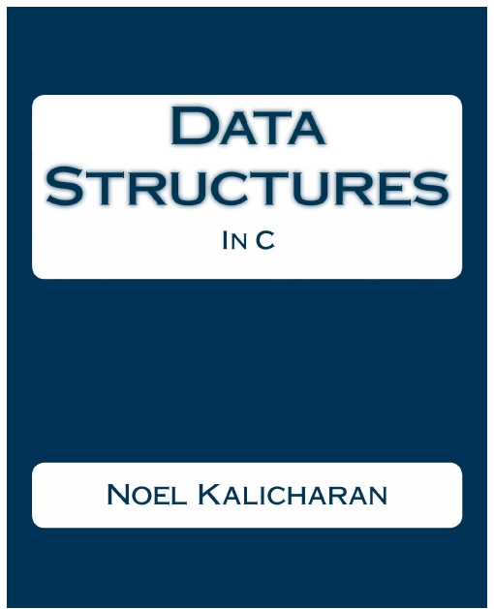

Bottom of Form

Top of Form

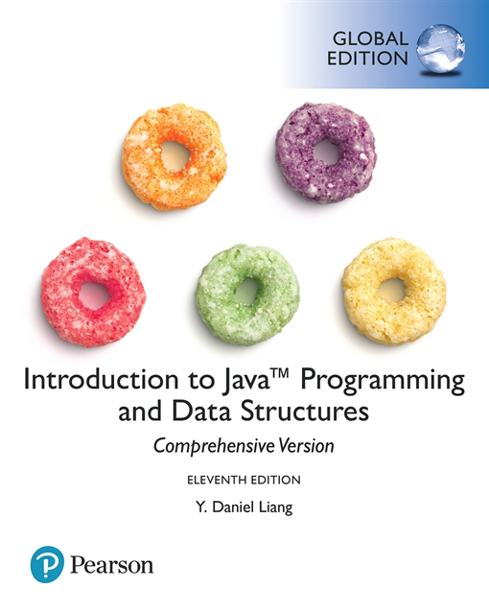

Bottom of Form

Top of Form



Bottom of Form









Copyright © 2019 Information and Documentation Center - [AASTMT](http://www.aast.edu/)

You are logged in as [SALMA ELSAYED BORHAM SOLYMAN](http://lmsweb.aast.edu/user/profile.php?id=30761) ([Log out](http://lmsweb.aast.edu/login/logout.php?sesskey=ckZVpuMNIp))

[Database Systems (IS273)](http://lmsweb.aast.edu/course/view.php?id=2682)